Name : Saswata Kumar Nayak
Superset id : 6363187
Mail id : 22052504@kiit.ac.in
University Roll : 22052504

WEEK - 02 : HandsOn Solutions

#1 - SOL Exercise - Advanced concepts

- Exercise - 1 : Ranking and Window Functions

Code :

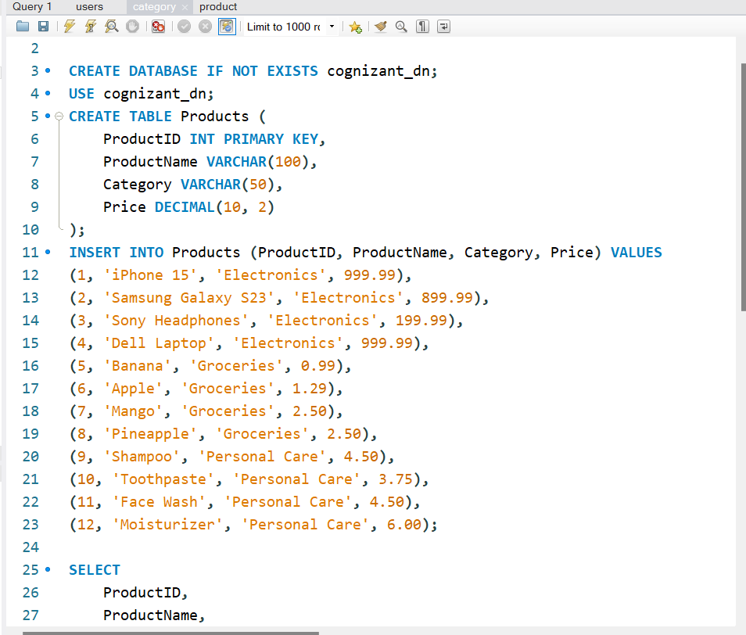
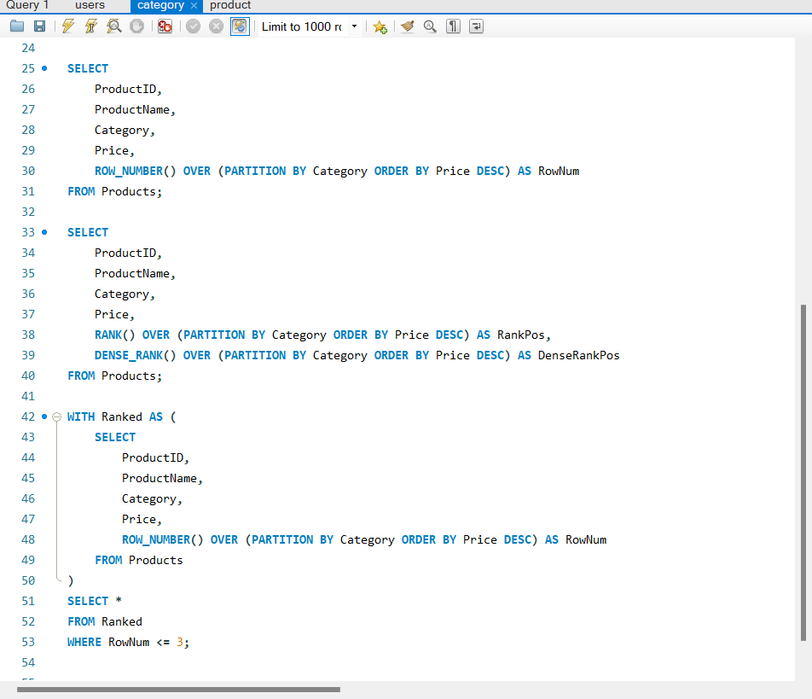
Output :
- Using ROW_NUMBER( )
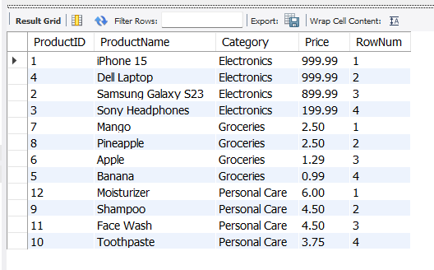

- Using RANK( ) & DENSE_RANK( )
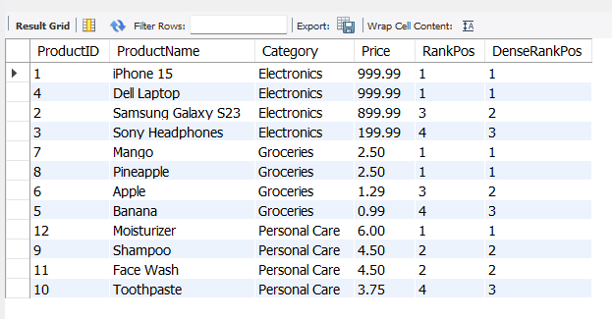
- Using PARTITION BY category & ORDER BY price DESC
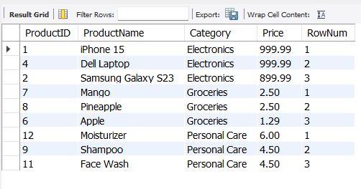
#2. SQL Exercise - Stored procedure
- Exercise 1: Create a stored procedure
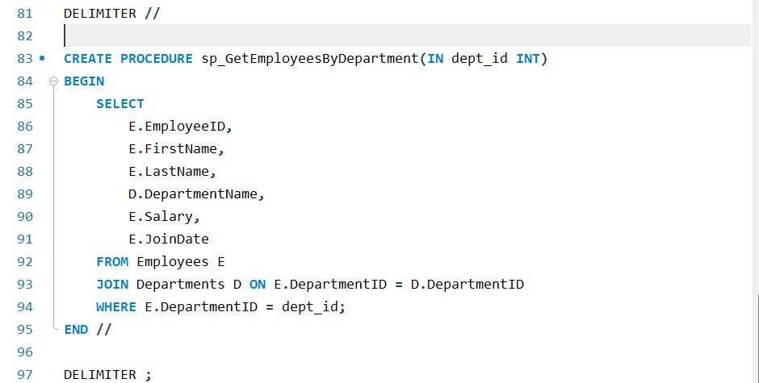
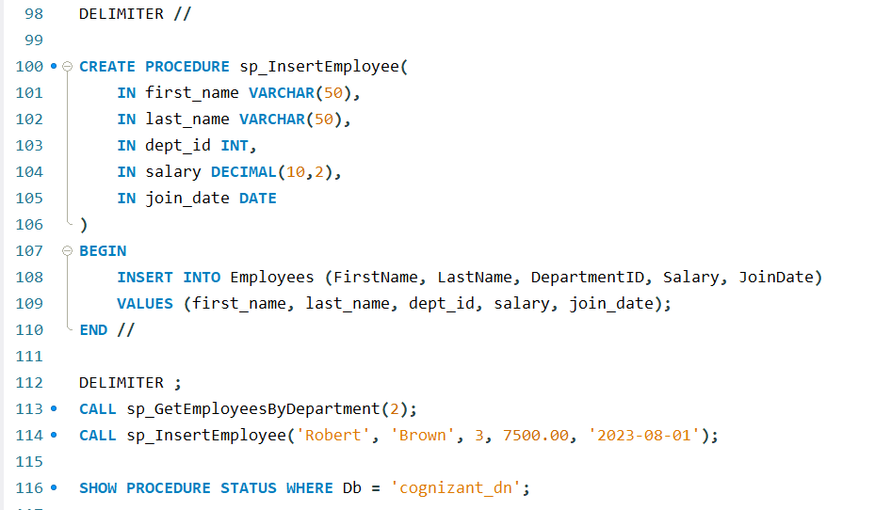
Output :
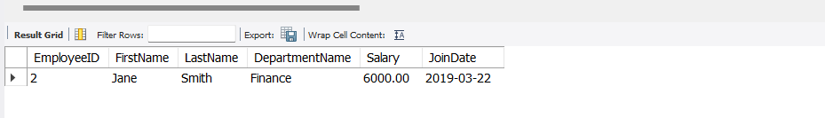
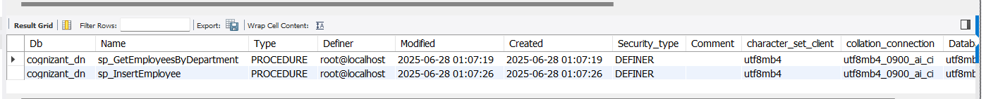
- Exercise 4: Execute a stored procedure
Code :
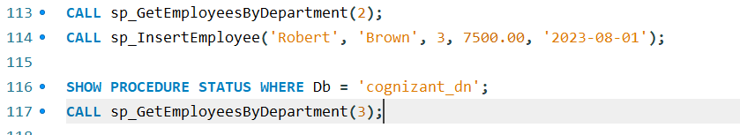
Output :
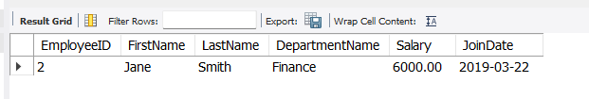
- Exercise 5: Return data from a stored procedure
Code :
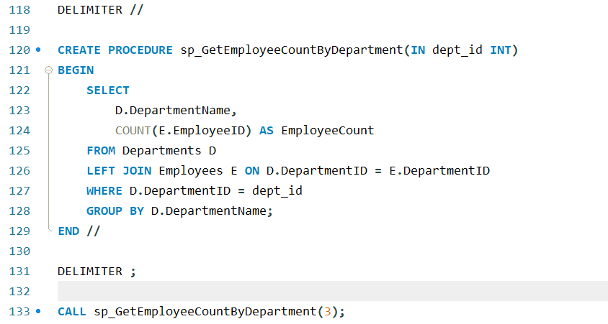
Output :
